

APIC Content

Management Update

Date: April 17, 2019

Version: 1.1

Table of Contents

1. Executive Summary 2
2. Introduction 2
   1. Purpose of This Document 2
   2. Who is the Intended Audience? 2
   3. Open Items for Future Revisions 2
   4. Document Metadata 2
   5. Document History 2
   6. Review Team 3
3. Signing in as Admin 3
4. Home page 4
   1. Header section 4

4.1.1 Site logo……………………………………………………………………………………………………………………….4

4.1.2 Portal Navigation Menus…………………………………………………………………...…………………………..4

4.1.3 Header User Menus……………………………………………………………………………………………………….5

* 1. Banner and cards 6
  2. Update Home page Banner and Card text 9
  3. Site footer 10

1. Getting Started 11
   1. Browse the available APIs 12
   2. Sign-Up 12
   3. Register an application 12
   4. Select a Plan 12
2. API Products 12
3. Apps 12
4. Support 13
5. Forum 13
6. FAQ 14
7. Blog 15

11.1 Add Blog…………………………………………………………………………………………………………………………………15

11.2 Edit Blog……………………………………………………………………………………………………………………………… 16

1. Update Profile 17

# 1 Executive Summary

IBM API Connect is a complete, modern and scalable API platform that lets you create, securely expose, manage and monetize APIs across clouds so that you and your customers can power digital applications and spur innovation.

API Connect lets you centrally manage your APIs across multi cloud deployments. It offers security-rich support to deploy and independently scale components based on workload across multiple diverse services and platforms, including public clouds like IBM Cloud, Amazon Web Services and Microsoft Azure, and private clouds like IBM Cloud. This innovative container- and micro services-based design provides you with unmatched scalability and performance.

# 2 Introduction

## 2.1 Purpose of This Document

The purpose of this document is to provide a blueprint on how to update content, Images and other relevant configurations in the APIC Developer portal. With this, one can update the content of the various pages of Admin portal as per the needs.

## 2.2 Who is the Intended Audience?

Primarily Administrator of the Internal and External portals who will involve in the content update of the portal pages intends this document for use.

## 2.3 Open Items for Future Revisions

The document needs to be matured and improved by getting feedback from project teams trying to apply the guidance on real use cases.

## 2.4 Document Metadata

## 2.5 Document History

|  |  |  |  |
| --- | --- | --- | --- |
| **Version** | **Date** | **By** | **Description** |
| 1 | 9/5/2019 | Dhanasekaran | Version 1.0 completed. |

# 2.6 Review Team

|  |  |  |
| --- | --- | --- |
| **Team** | **Reviewer** | **Involvement** |
| Onsite | Ananta Guha |  |
| Onsite | Darwin |  |

# 3 Signing in as Admin

1. Click Login link which is available at the top right of the portal



1. Enter User Name and Password and click submit.

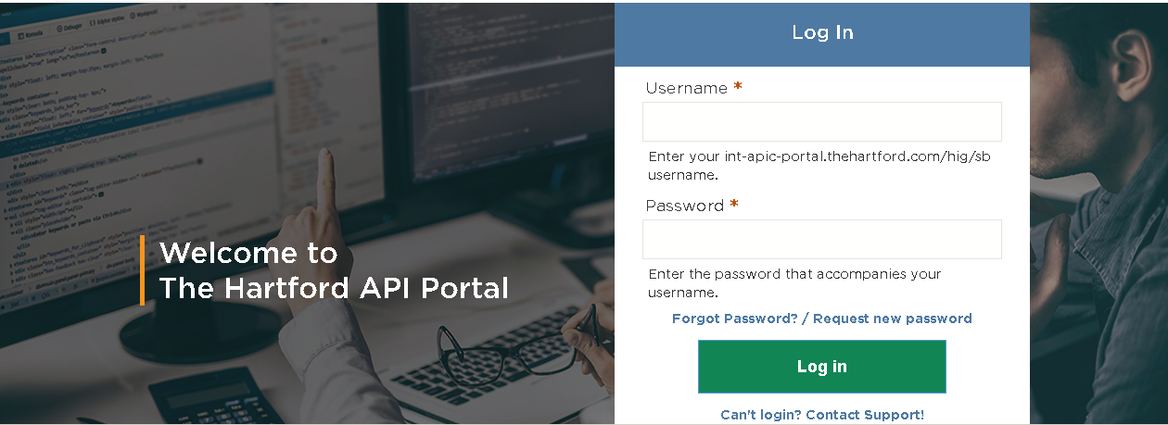

1. After Login, you can see the administrator options and able to do the content update.



# 4 Home page

## 4.1 Header section

**4.1.1 Site logo**:

1. Login as Admin
2. Navigate to Home » Administration » Appearance » Settings » Logo image settings.

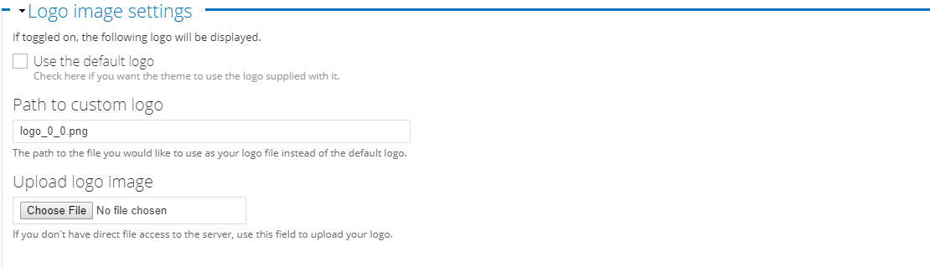

1. Upload the logo and click save.

**4.1.2 Portal Navigation Menus:**

1. Login as Admin
2. Navigate to Administration » Structure » Menus » Main Menu

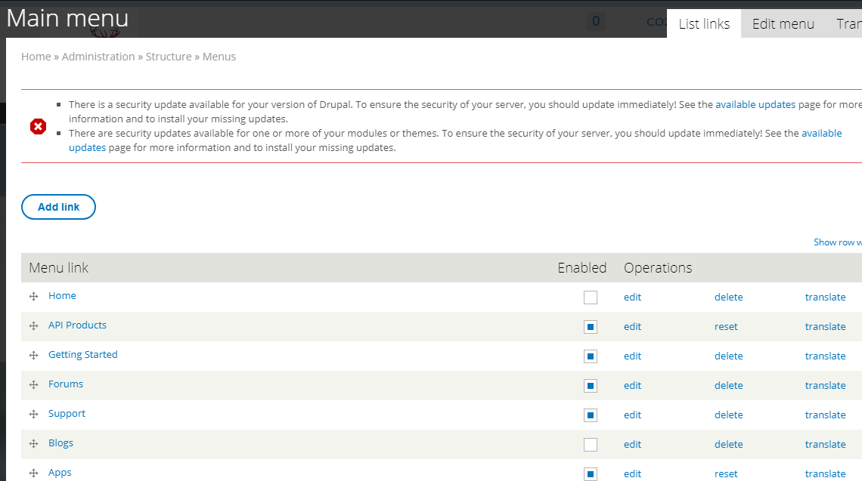

1. API Products, Forums, Apps page should be assigned only for authenticated user.

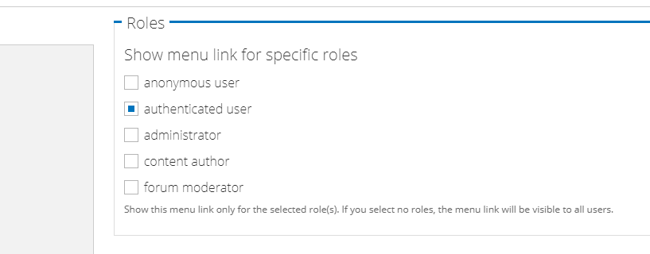

* API Products – assign only to authenticated user.
* Getting Started
* Forums - assign only to authenticated user.
* Support
* Blogs – Menu link should be disabled.
* Apps - assign only to authenticated user.

**4.1.3 Header User Menus:**

1. Login as Admin
2. Navigate to Administration » Structure » User menu

* My bookmarks - Disable
* Create organization – Disable
* User account
* My Organization
* Logout

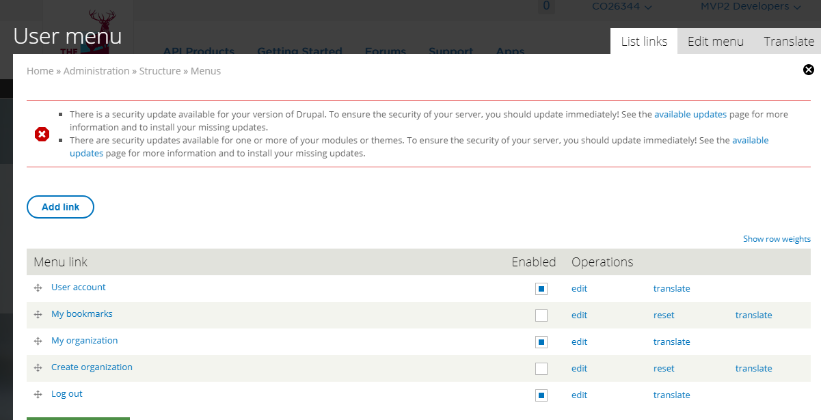

## 4.2 Banner and cards

1. Login as Admin.
2. Mouse over on the right corner of the banner image. Click Edit Panel.

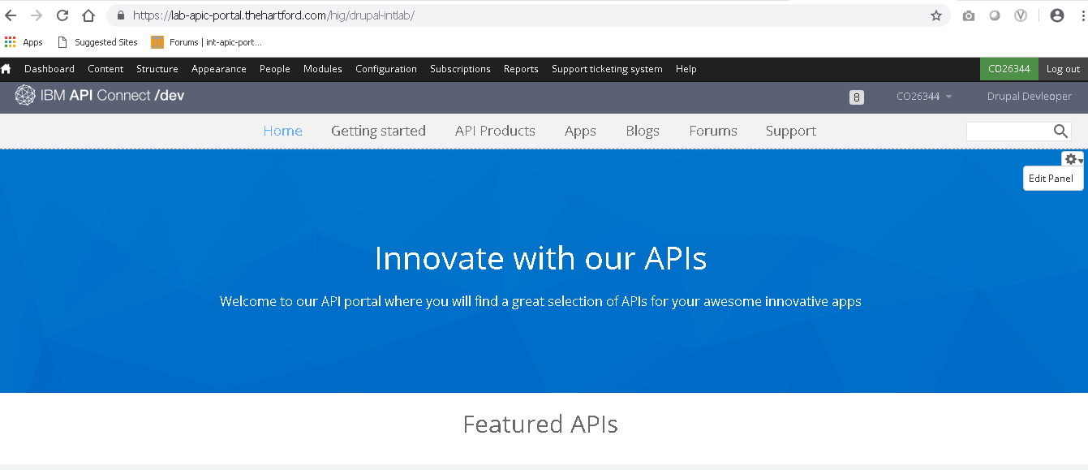

1. Remove Welcome Banner, Featured APIs Title, Featured API and Social block.

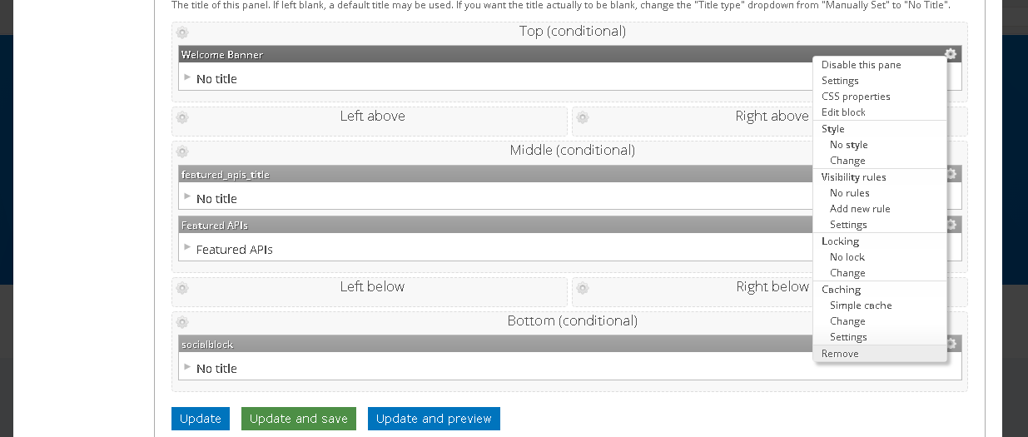

1. Click Add content.

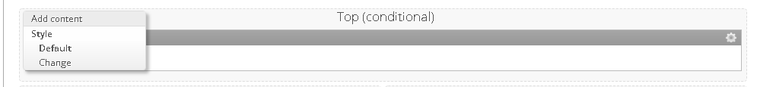

1. Click “New custom content”.

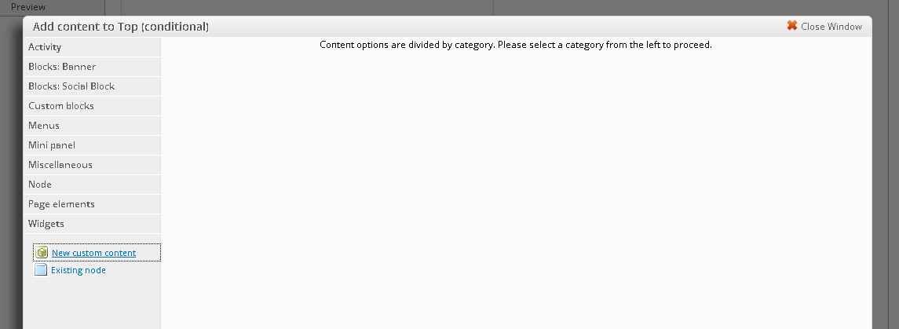

1. Upload the banner image to server inside the sites/all/themes/hig_connect_theme/images folder
2. Migrate the banner html contents to Internal/External Environments separately.

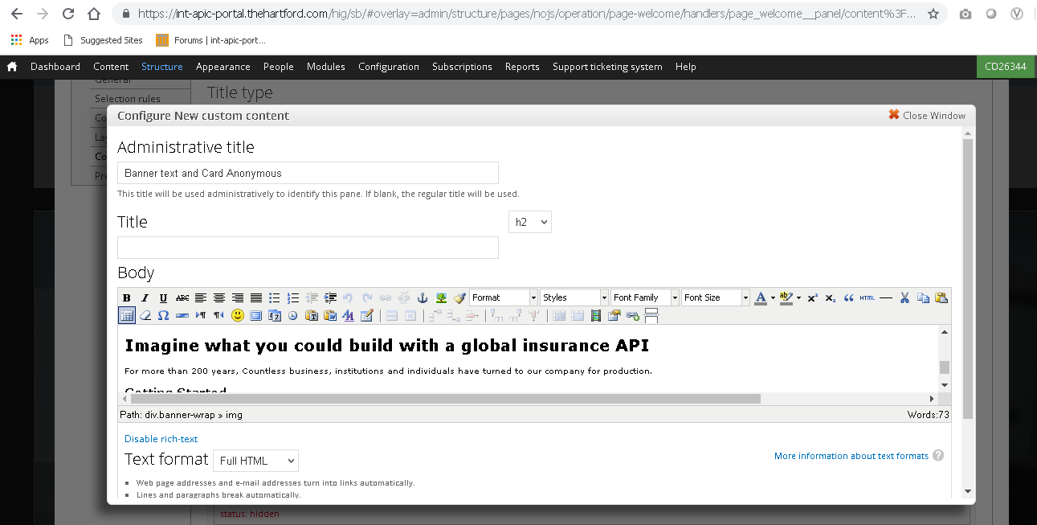

1. Partner with us – Link it to /contact. This is an inbuilt contact form created from Drupal end in the user settings.
2. Getting started – link it to /start page.
3. Click Update and Save.



You have done.

## 4.3 Update Home page Banner and Card text

1. Login as Admin
2. Mouse over on the right corner of the banner image. Click Edit Panel.



1. Click Edit.

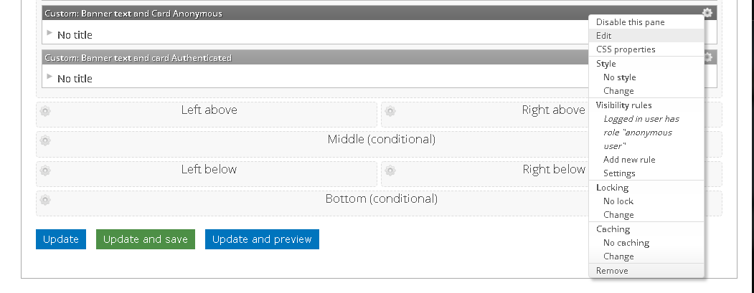

1. Update the Banner text/Getting started/Partner with Us as you want.



1. Click Update and Save.
2. You have done.

## 4.4 Site footer

1. Login as Admin
2. Navigate to Administration » Structure » Blocks » Developer portal footer

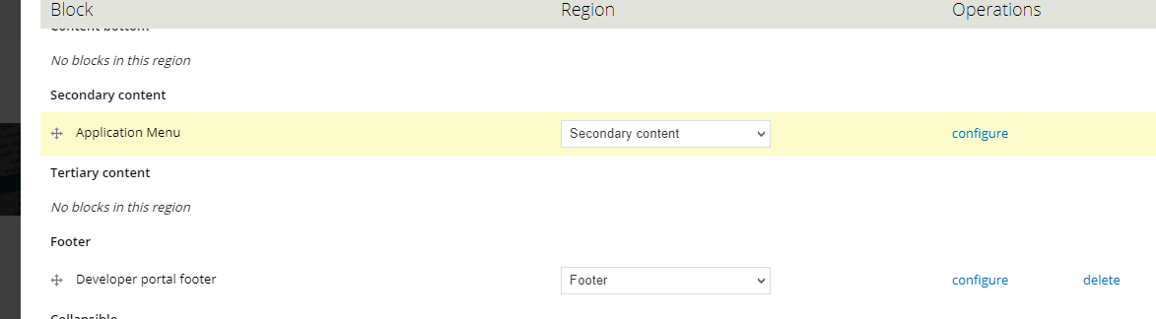

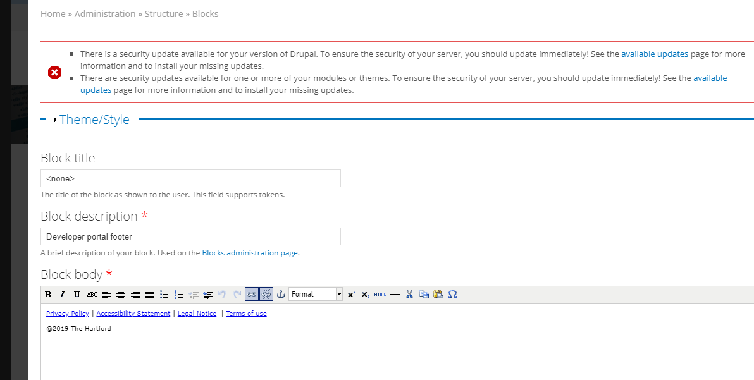

For the footer links, the following configuration has been made.

* Sign in as admin
* Navigate to Content🡪Filter as basic page🡪Privacy Policy

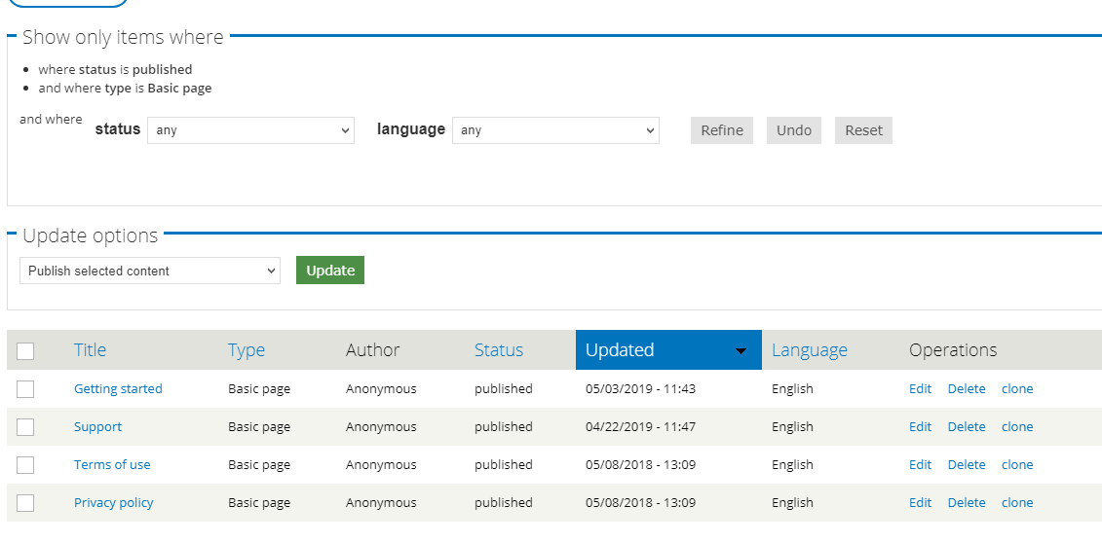

* Privacy Policy – <https://www.thehartford.com/online-privacy-policy>

As we have not received all content, whatever we have, we have edited in the content of privacy policy .Once we get more content we will add accordingly in the body.

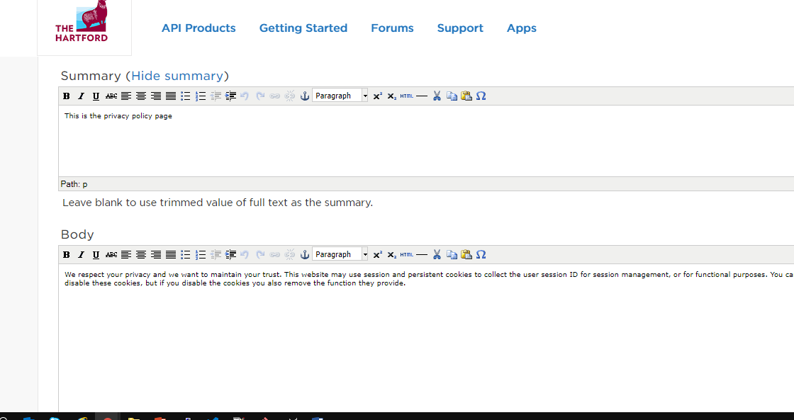

* Accessibility Statement - <https://www.thehartford.com/accessibility-statement>

As we do not have the content for this basic page, we have redirected it to the Hartford site URL

* Legal Notice - <https://www.thehartford.com/legal-notice>

As we do not have the content for this basic page, we have redirected it to the Hartford site URL

* Terms of use - <https://int-apic-portal.thehartford.com/hig/sb/terms>

As we have not received all content, whatever content we have, we have edited in the content of terms of use .Once we get more content we will add accordingly in the body. The following configuration has been made.

* Sign in as admin
* Navigate to Content🡪Filter as basic page🡪Terms of use

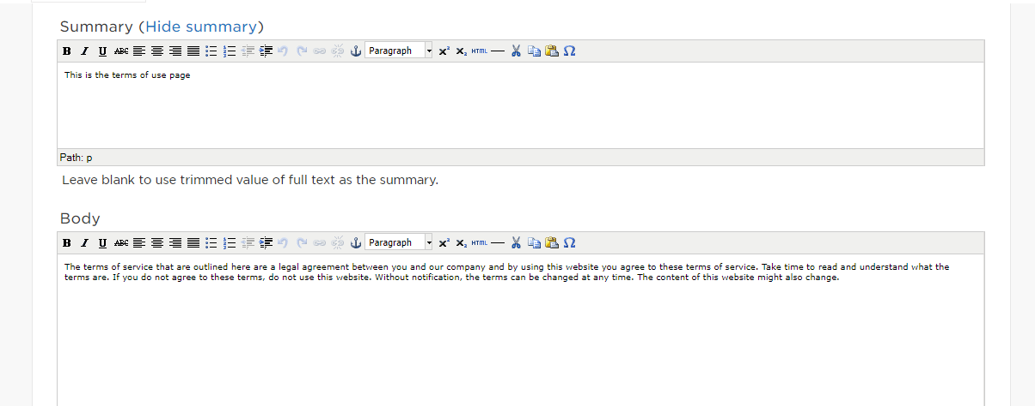

# 5 Getting Started

1. Login as Admin
2. Navigate to Administration » Content» Basic Page » Getting Started

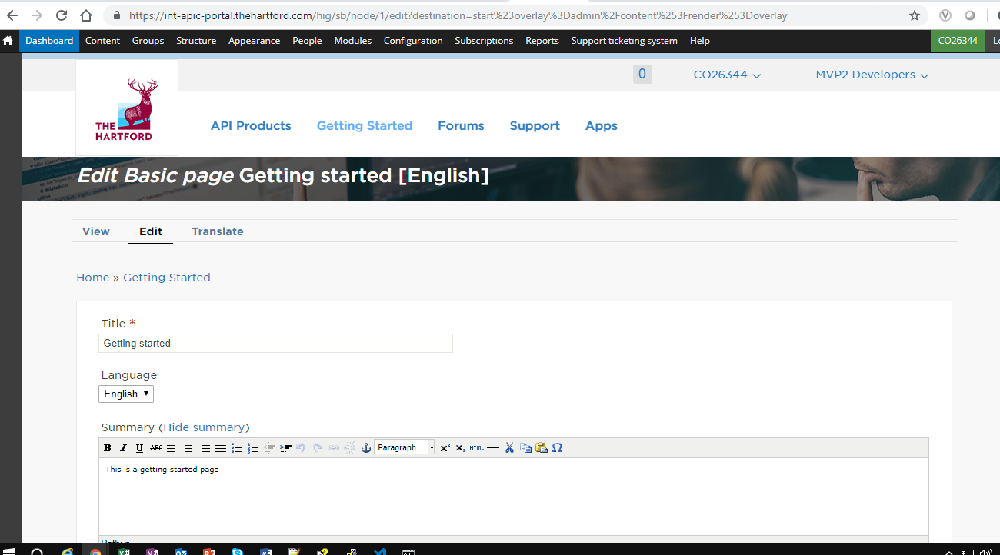

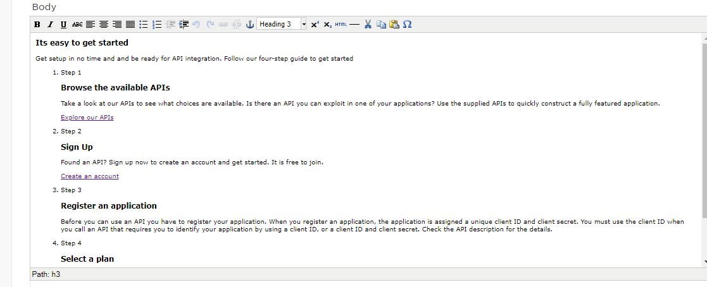

1. Go to Body Summary and click html section. We can configure the Getting started page contents.

## 5.1 Browse the available APIs

1. All users must be able to click on 'Explore our APIs' button and system must navigate to the API Products page.

## 5.2 Sign-Up

1. EXTERNAL USERS: Create Account button must be removed. On clicking the sign up button, a new popup window should open which will contain text box to include group email address to request registration.
2. INTERNAL USERS: Users will redirect to /register page. Create Account button must be visible; internal users must be allowed to register by this process.

## 5.3 Register an application

1. EXTERNAL USERS: Not allowed to use this function. It will be done by Hartford Admin function.
2. INTERNAL USERS: User has to be redirected to <https://thehartford.service-now.com/ess>

**5.4 Select a Plan**  
 9. EXTERNAL USERS: Not visible INTERNAL USERS must be able to select a plan.

# 6 API Products

There is no specific configuration for this page.

# 7 Apps

There is no specific configuration for this page.

# 8 Support

1. Login as Admin
2. Navigate to Administration » Content» Basic Page » Support and click Edit.

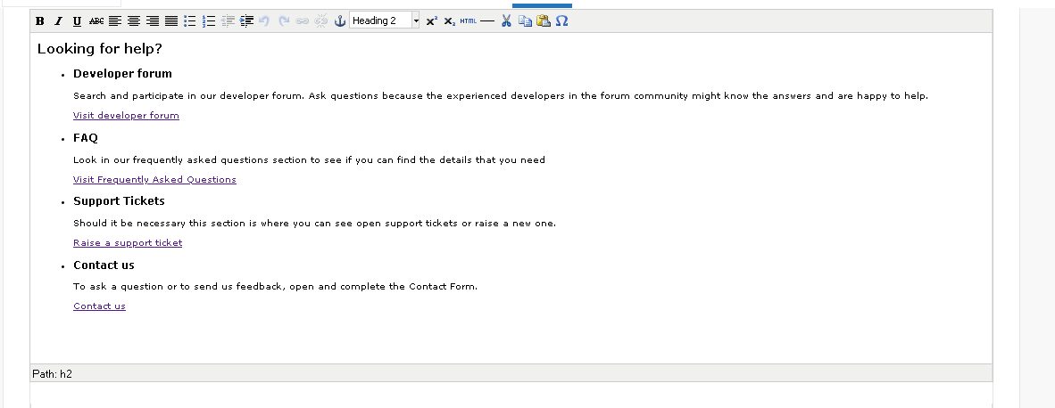

1. You can update the content for the Support page.

# 9 Forum

**Add Forum Container:**

1. Login as Admin
2. Go to[Administration](https://int-apic-portal.thehartford.com/hig/sb/admin) » [Structure](https://int-apic-portal.thehartford.com/hig/sb/admin/structure) » Add Container

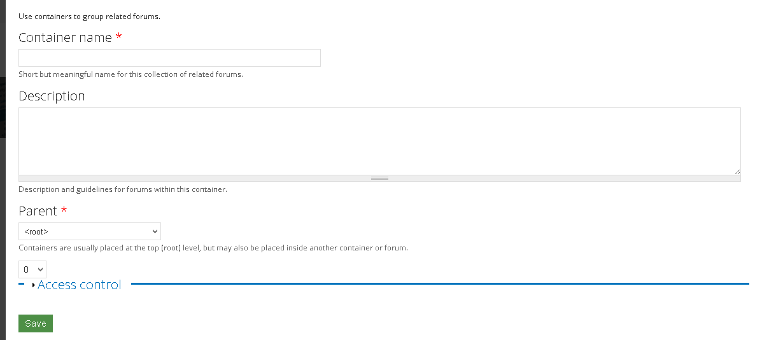

1. Enter container name, Description and Parent. Click Save.

**Add Forum:**

1. Login as Admin
2. Go to[Administration](https://int-apic-portal.thehartford.com/hig/sb/admin) » [Structure](https://int-apic-portal.thehartford.com/hig/sb/admin/structure) » Add Forum

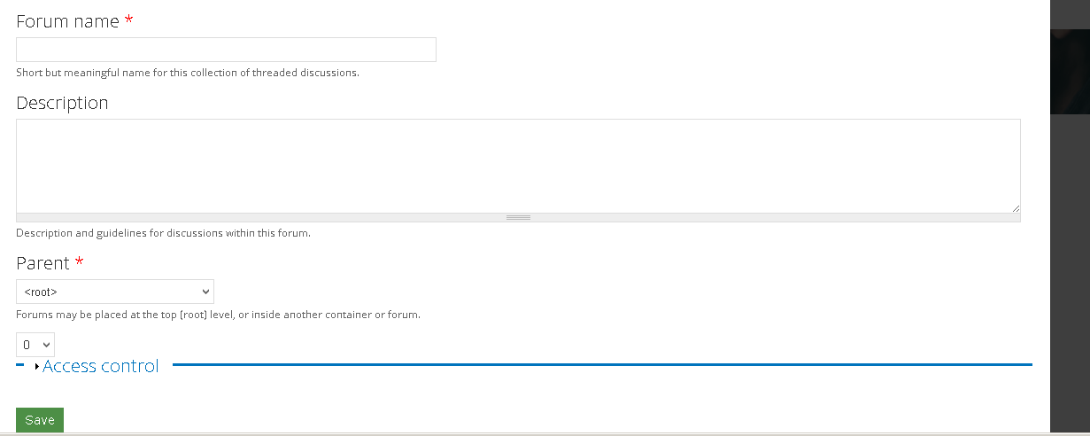

1. Enter Forum Name, Description and Parent. Click Save.

# 10 FAQ

1. Login as Admin
2. Go to Content. Filter only FAQ contents.

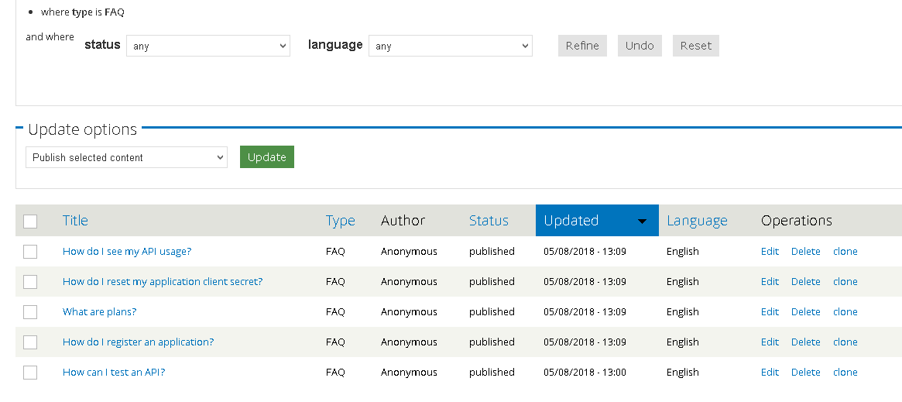

1. You can edit any FAQ content here.

# 11 Blog

## 11.1 Add Blog

1. Login as Admin
2. Go to Content-> Add content-> Blog Entry.

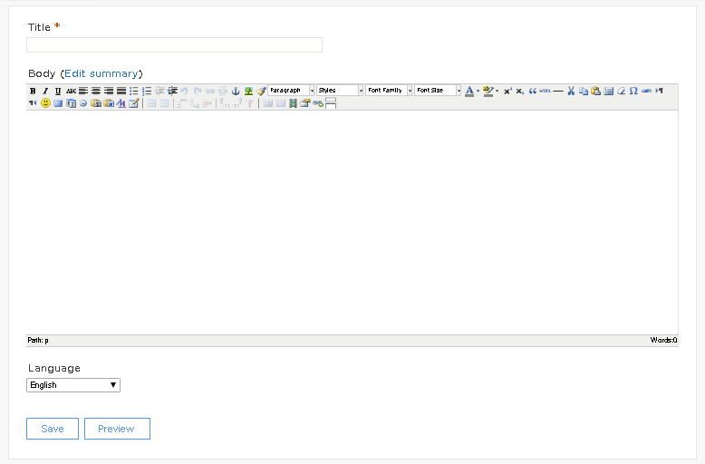

1. Enter Title and Body and Click Save.

## 11.2 Edit Blog

1. Login as Admin.
2. Go to Content. Filter only Blog Entry.

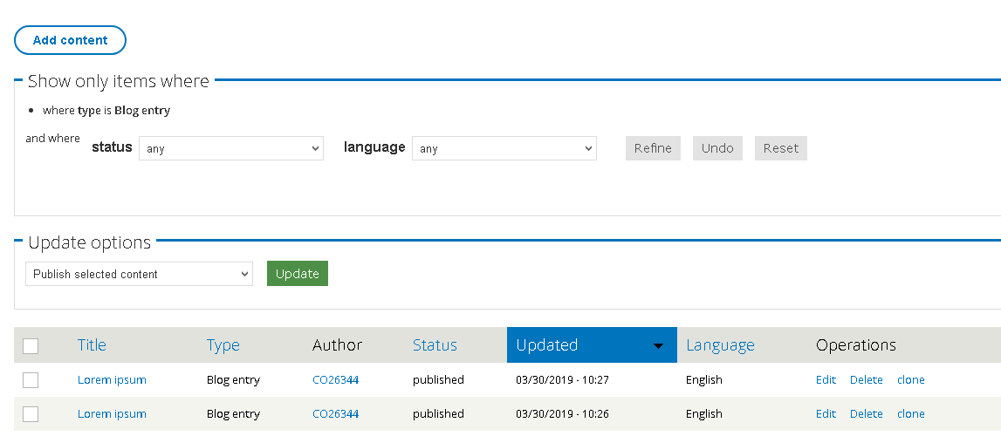

1. You can Edit any Blog content here.

# 12 Update Profile

1. Login with your account.

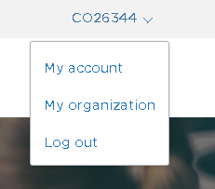

1. Click My Account
2. Click Edit

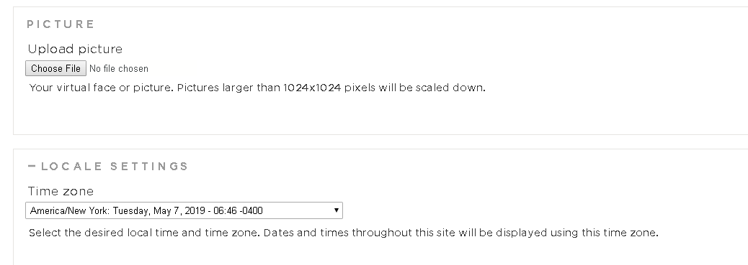

1. You can update Profile picture and change time zone with this profile update form.